Release Planning Document
Course: COSC 4P02
Date: January 17th, 2025
Project Title: Feastly (Recipe-App)
Group Number: 18
Group Members:
- Roger Li
- Sahil Modi
- Troy Bello
- Samrat Gautam
- Ridham Elhance
- Abdelgelil Mohamed
- Michael Duru

1. Introduction
Feastly is a digital platform designed to revolutionize meal planning and recipe sharing. It enables users to discover new recipes, save their favorites as recipe cards, share their culinary creations with others, and create personalized meal plans. The platform aims to represent the recipes in simple yet informative cards through a simple and clean user interface designed for web. This document outlines the user stories, backlogs, and release plan, serving as a foundation for the development and successful implementation of the project.

2. User Stories
ID  1 | Title  User Interface | Description  As a user, I want clean and intuitive User Interface to ensure that I can navigate the app fast and see less fluff and more functional elements. | Acceptance Criteria  Conducting tests with stakeholders that are not involved in the development process to individually test each component and make sure that each feature is navigable, seen and understood.  Following UI/UX principles such as accessibility, consistency, usability, user centricity, etc. | Priority  High
2 | Save a Recipe | As a user, I want to save a recipe from the recipe page, so that I can access it later easily. | Add a "Save" button to the recipe page.  Link the button to the user's account for saving.  Create a database table for saved recipes.  Test saving functionality with different accounts. | Medium
3 | Edit Saved Recipes | As a user, I want to edit saved recipes, so that I can customize them to my preferences. | Add an "Edit" button to saved recipes.  Allow editing of ingredients, instructions, and titles.  Save edited recipes back to the database.  Test editing functionality with various recipe types. | Medium
4 | Share Saved Recipes | As a user, I want to share my saved recipes with other users, so that they can enjoy the recipes too. | Add a "Share" button to saved recipes.  Implement sharing via email or social media.  Include privacy settings for shared recipes.  Test the sharing functionality for different platforms. | Medium
5 | Recipe page to display details | As a user, I want each recipe page to display details clearly, so that I can easily read and follow instructions. | Design the layout for the recipe page (UI/UX design).  Fetch recipe details from the database.  Implement the front-end display (title, ingredients, instructions).  Add responsiveness for mobile and desktop views.  Conduct user testing for readability and clarity. | Medium
6 | Search Using AI Suggestions | As a user, I want to search using AI suggestions, so that I can discover recipes based on vague inputs or preferences. | Integrate an AI-based search algorithm.  Develop an intuitive search bar interface.  Test the AI with vague inputs (e.g., "quick dinner ideas").  Optimize the AI for speed and accuracy. | Low
7 | Food Discovery Categories | As a user with little time, I want quick and simple recipes which are healthy and nutritious while also not requiring a lot of preparation or skill to cook since I’m a beginner. | Implement categories of discovery for different recipes. In this case, a “Student Favorite” category would help for quick and easy yet healthy foods. | Low
8 | Alternative or Substitute Ingredients | As a user, I want to find good alternative suggestions for ingredients that I don’t have available. | Allow manual suggestions for recipes. Alternatively, have an AI based analysis of a recipe and let it decide for you what ingredients can be substituted or removed. | Medium
9 | Nutrition Facts | As a user but someone who wants to take care of their body, I want nutrition information on all recipes even if they are approximate. This is to ensure that I know what I’m consuming | Implementing manual nutrition facts place where original posters of recipes can change it. To ensure it is valid, the AI can look at it to see if it is roughly okay. | Medium
10 | Less fluff, more straight to the point recipe instructions | As a user, I want less “hyping up” a recipe talks and more straight to the point instructions. I hate having to look around the fluff to find out the actual recipe. | AI summary for “short and simple recipe summary” button which will generate a short summary in-chat | Low
11 | Likes and Comments Feature | As a user, I want to view the likes and comments to see whether the recipe turned out good for others or if others have better recommendation to add on top of this recipe. | Implement a likes and comments feature per post. | Medium
12 | Offline access and lightweight app. | As a user of a slower device, I want the app to load quickly and work offline to certain extent, at least for my saved recipes so I can access them whenever. | Test app on multiple browsers, devices with varying system specifications to ensure it does not lag or freeze.  Allow downloading recipe cards/sheets for given recipe. | Medium
13 | Recipe Cards | As a user, I want a clean and quick way to save my recipes as recipe cards downloaded in formats like word doc, PDF, image formats, etc. | Implement a quick recipe card download feature. | Medium
14 | Discovery | As a user, I sometimes don’t know what to make so I want a discovery feature which tells me what I could make tonight, even if it’s a little out of my skill level. | Implement a “discovery” page which includes new recipes and a search algorithm to search through tags or ingredients. | Medium
15 | User Interface | As a user, I want a clean and intuitive User Interface to ensure that I can navigate the app fast and see less fluff and more functional elements. | Using test-based development, we can ensure that pages are clean, and no extra “fluff” or unnecessary junk is in our UI and functionality. Clean and simple is the goal. | High

3. Product Backlog
Splits can are roughly based on

Task | Associated User Story | Priority
Card: Using React, create a component holding all details in a food card preview. |  | High
Card: Create a database to hold card’s details using Firebase and Firestore | 2 | High
Card: Create interactive buttons to download a card into a sheet, using database retrieval |  | Medium
Card: Add an expanded (and separate) recipe page with detailed information about the recipe. | ID: 2 & 5 | High
Card: Implement a gallery/carousel to hold images for the cards | ID: 2 | Medium
Card: Button to save recipes will open a dropdown of a user’s food recipe albums where they can save everything |  | Medium
Card: Utilize React to dynamically edit the food card and update it in the database when clicked on the “update” button |  | High
Card: Use React & Databases to properly show likes and comments under a card |  | Medium
Card: Create a button that only the owner can see that says “edit recipe” |  | Low
Recipe Cards: Test the usage of editing recipes with correct and incorrect data to check if system fails | ID: 2 & 13 & 3 | Medium
Home & All: Implement a home page UI using React with a navbar UI and a "following” tab UI | ID: 15 | High
All Pages: Navbar UI will hold pages: home, equipment, discovery, about, etc. - using React | ID: 15 | High
All Pages: Following tab UI will hold small cards of followed chefs and friends - using React | ID: 15 | High
All Pages: Implement correct navigation for all pages in the navbar and following tabs |  | High
All Pages: Implement scrolling down for the following tab (and a scroll bar) |  | Low
All Pages: Implement a search bar and a simple search algorithm that will live search the following tab depending on what you type in the search bar |  | Low
Discovery: Implement a grid UI which holds a database of publicly shared recipes |  | Medium
Discovery: Implement a special more compact card using React which condenses an image and vital information for the users to see before they enlarge the card |  | Medium
Discovery: Implement a functionality where the user can click on a card and it will expand into a proper card with all the information, instructions, etc. |  | Low
Discovery: Have a basic search algorithm which can search using pre-made tags or recipe-facts |  | High
Discovery: Create filters which will filter only the things the user wants to see |  | Low

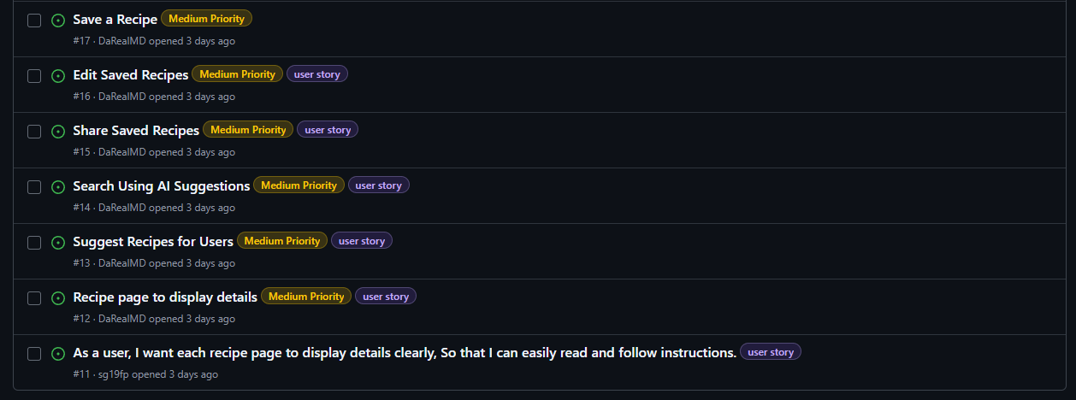

4. Sprint Backlogs
Sprint | Tasks
1(Jan 13-Jan 20) | Release planning Document  Assign teams  Planning the 2nd Sprint: Tasks, backlogs, and roles
2(Jan 20- Jan 27) | Before Tasks:  Frontend Team: Main menu, Home page, Header and Footer.  To do:  -Roger: Edit / Double check the Relationship Diagram.  -Team: Use Figma, React, and HTML Language to figure out the starting components.  Backend Team: Figure out Firebase, and FireStore.  -Use the Relationship Diagram to help store data
3(Jan 28 – Jan 31) | Release Planning Document feedback review  Frontend and Backend team discuss on hardware and design  Frontend: Mockup barebone website created for design discussion  Basic components and theme should be decided and some completed
4(Feb 3 – Feb 7) | Release Planning fix finalization  To Do:  Frontend: - Website mockup base should be mostly completed, then discussion on possible designs  Backend: Keep working on firebase and firestore to finish organizing data.
5(Feb 10 – Feb 14) | To Do:  Frontend: - Website mockup base and design would be discussed  Backend: Create a library from the firebase and firestore to give to the frontend team to start incorporating the code and testing
6(Feb 17 – Feb 21) | To Do:  Frontend: - Website (base and design) should be reaching final stage to prepare for feature addition and tweaking (whilst trying to link functionalities with backend)  Backend: “Working” making sure components and data is being stored and transferred properly
7(Feb 24 – Feb 28) | To Do:  Frontend: - Linking website functionalities with backend  Backend: Start work on the mobile app, to which, it will be incorporated with the website in some way/shape/form.
8(March 3rd – March 7th)  CHECK WEEK! | To Do:  Front end: Work on user-friendliness and performance on website (maybe app)  Making sure the website and possibly its app are Userfriendly and working smoothly  Back end: Either check on both app and site/ keep working on the app and data/ else, help the front-end team have a beta product.
9(March 10th – March 14th) | -To be determined, (Based off progress)  Whole team: Discuss AI implementation and other useful features to add or upgrade.

5. Tool Screenshots
Sprint 1 - Release planning Document
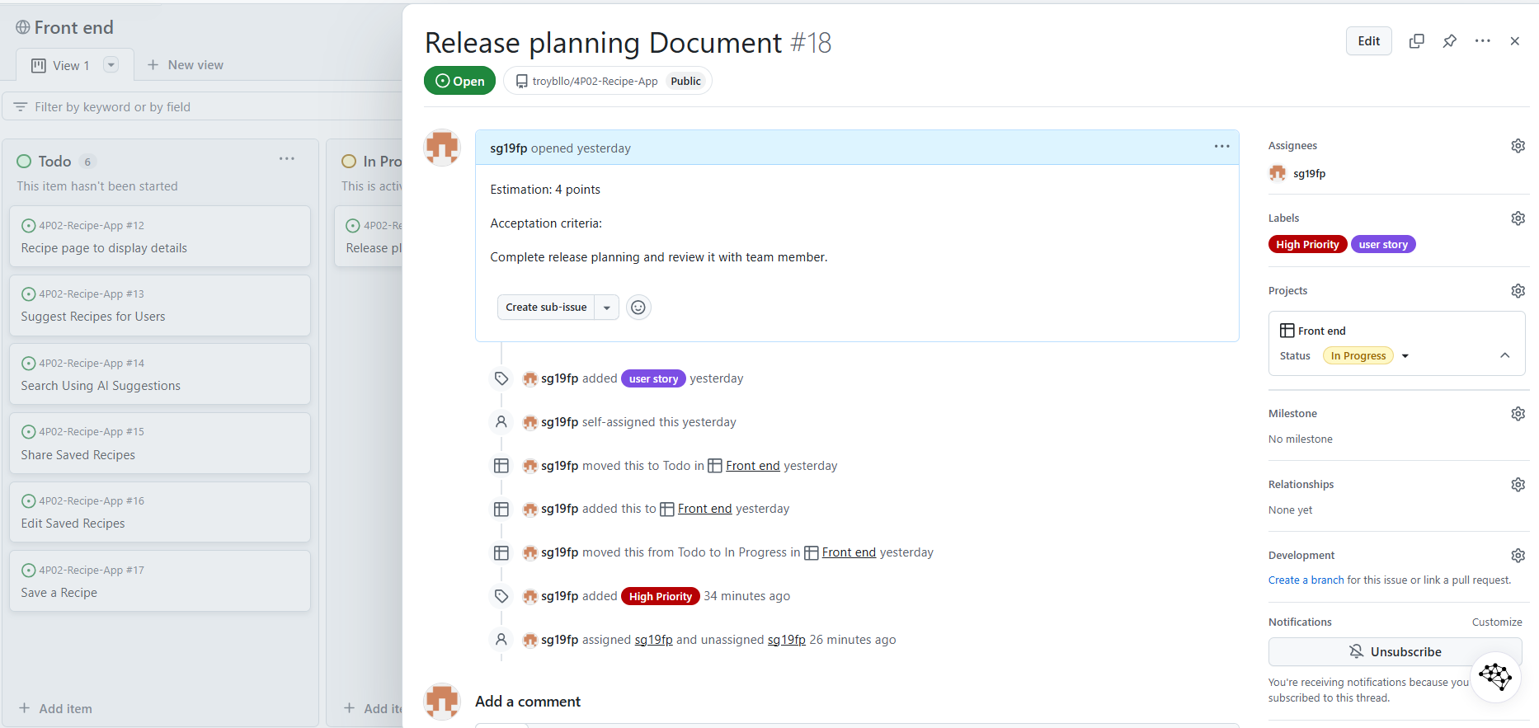
Backlog:
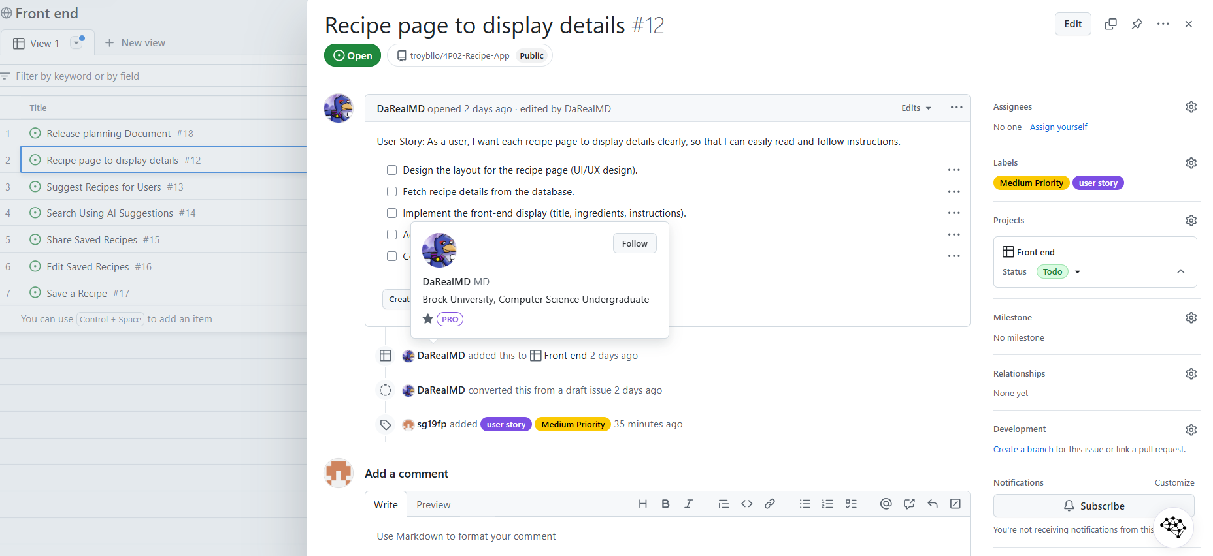

Figma Design:
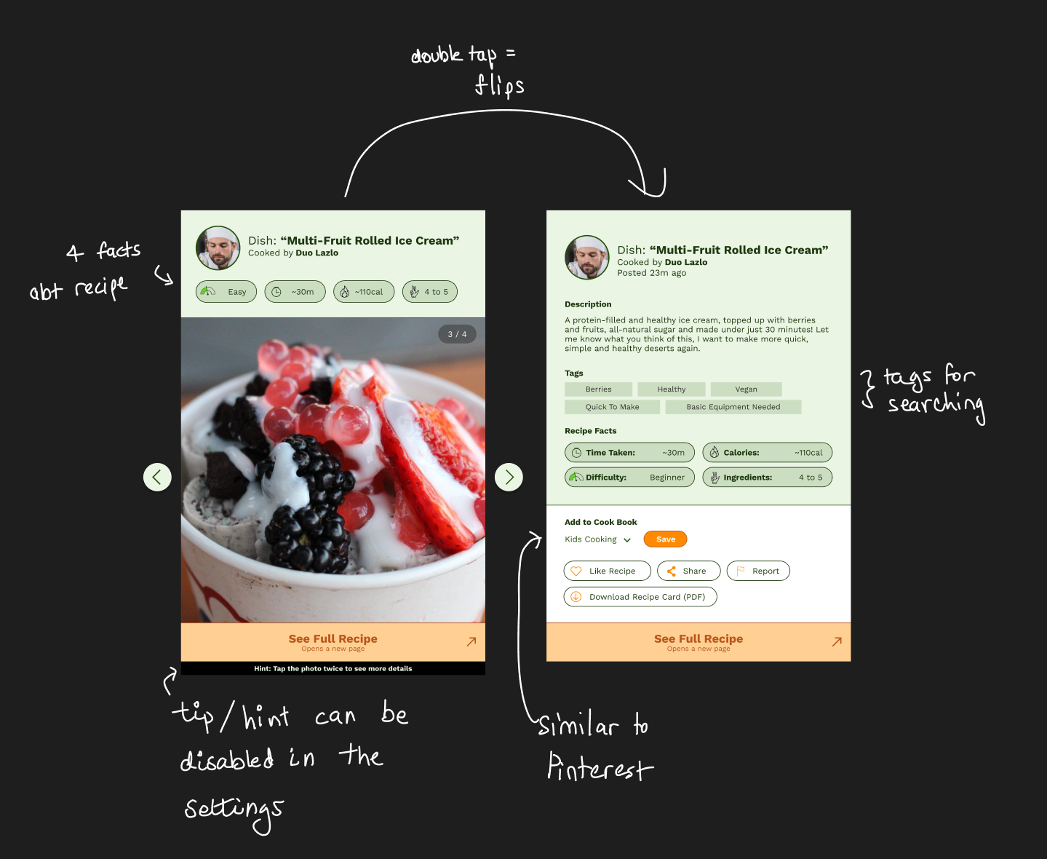
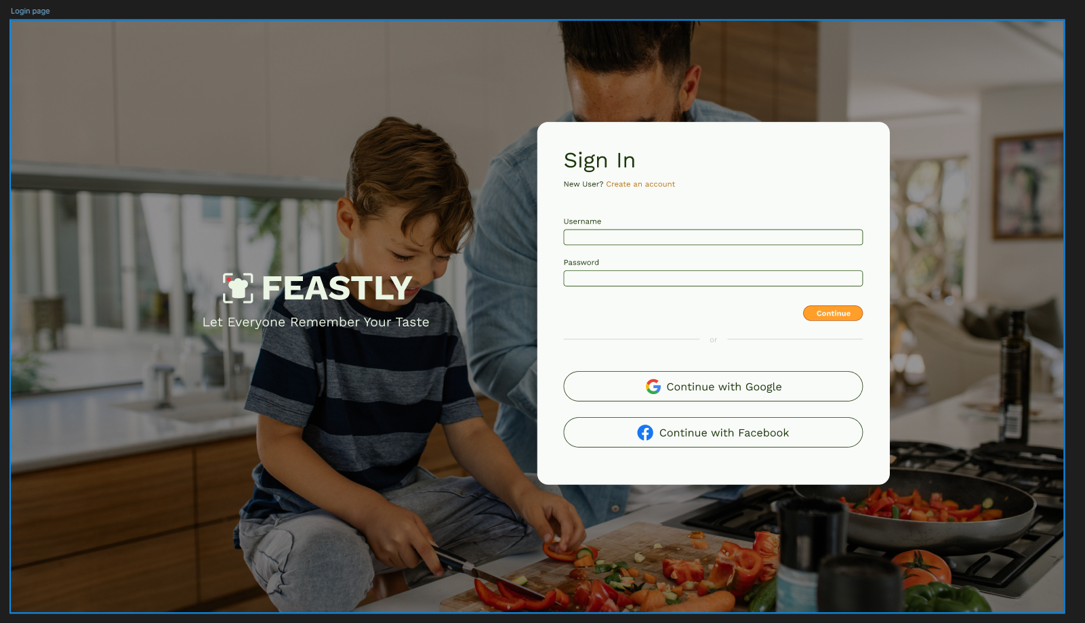
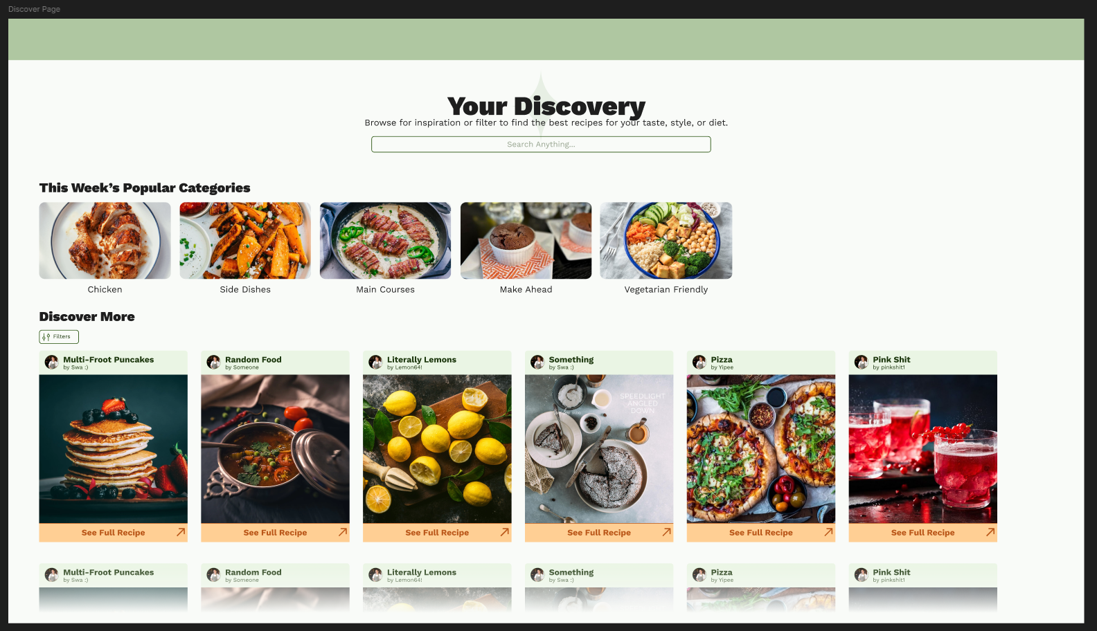
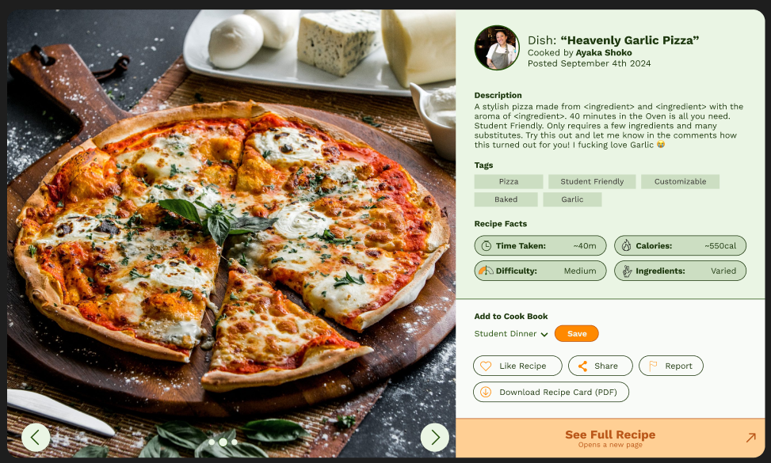
Survey (Showing only two questions)
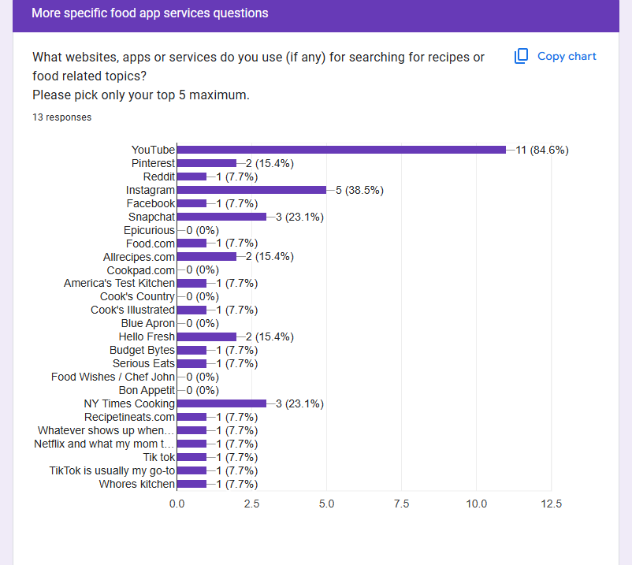
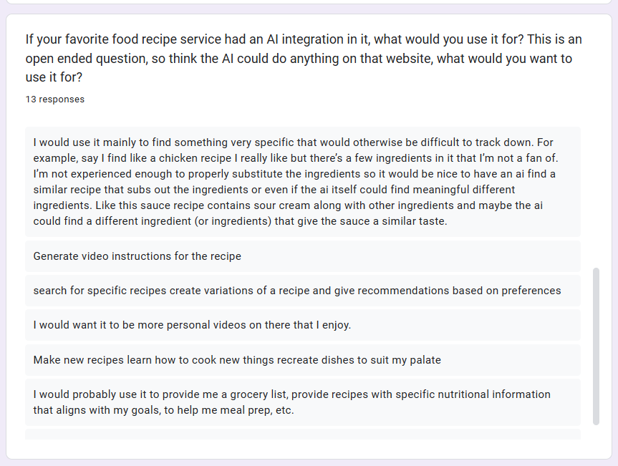

6. Team Contributions
Team Member | Contribution
Samrat Gautam | Facilitate meetings- took meeting minutes, Created User Stories, App design
Ridham Elhance | Initial backend setup and organization
Mohamed Abd El-Gelil | Setup Firebase account , Database setup
Chidiebube Michael Duru | User stories, project board setup and planning, Frontend
Sahil Modi | User Stories, App Design, Initial Survey Creation (For User Stories)
Roger Li | Initial Frontend setup and project backlog.  Relation Diagram setup.
Troy Bello | Frontend framework Setup and User stories

7. Challenges and Next Steps
Challenges Faced:
Initially, team communication was smooth; however, during the first week, we needed to pick a common meeting time. After discussion, we agreed to use lecture time as it was convenient for everyone. Dividing the team into frontend and backend groups was manageable but posed challenges due to varying levels of familiarity with certain tools and software among team members.
One challenge we faced was the diverse knowledge of knowledge, however, the team quickly came to an agreement with which technology to use to favor our app service and not compromise on any features.
Next Phase Actions:
- Front End and Back End learning and getting comfortable with their respective technologies.
- Further refine the sprint backlog to ensure clarity and alignment.
- Focus on completing Sprint 1 tasks, with special attention to balancing team workloads based on software proficiency.
- Continue leveraging lecture time for effective team coordination and progress tracking.

8. Appendices


